**Task 1: Scan Your Local Network for Open Ports**

**Objective**: Learn to discover open ports on devices in your local network to understand network exposure.

**Tools**: Nmap

----------------------------------------------------------------------------------------------------------

1. **Nmap Installation:**

$sudo apt update

$sudo apt install -y nmap wireshark

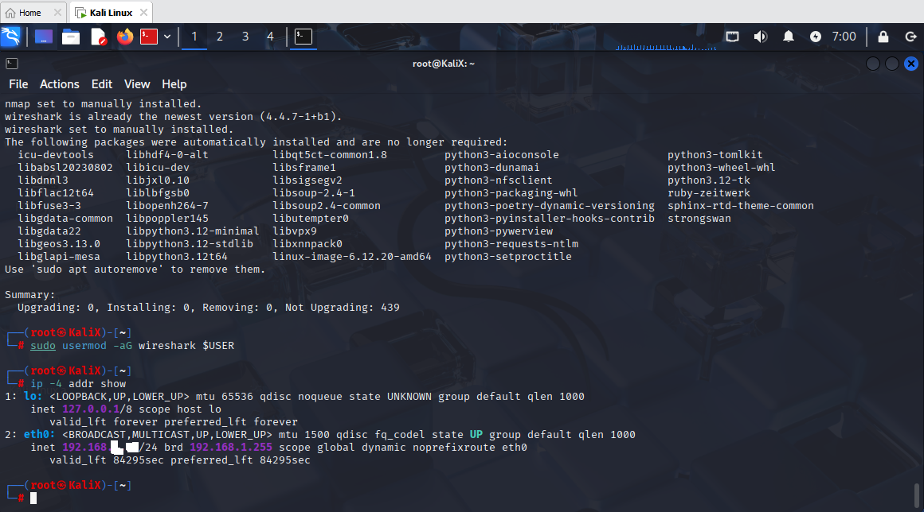

* Update and Install nmap and Wireshark

1. **IP Scan - Discover your local IP range**

**$ip -4 address show**

* : lo: <LOOPBACK,UP,LOWER_UP> mtu 65536 qdisc noqueue state UNKNOWN group default qlen 1000

inet 127.0.0.1/8 scope host lo

valid_lft forever preferred_lft forever

2: eth0: <BROADCAST,MULTICAST,UP,LOWER_UP> mtu 1500 qdisc fq_codel state UP group default qlen 1000

inet 192.168.--.--/24 brd 192.168.--.-- scope global dynamic noprefixroute eth0

valid_lft 84295sec preferred_lft 84295sec

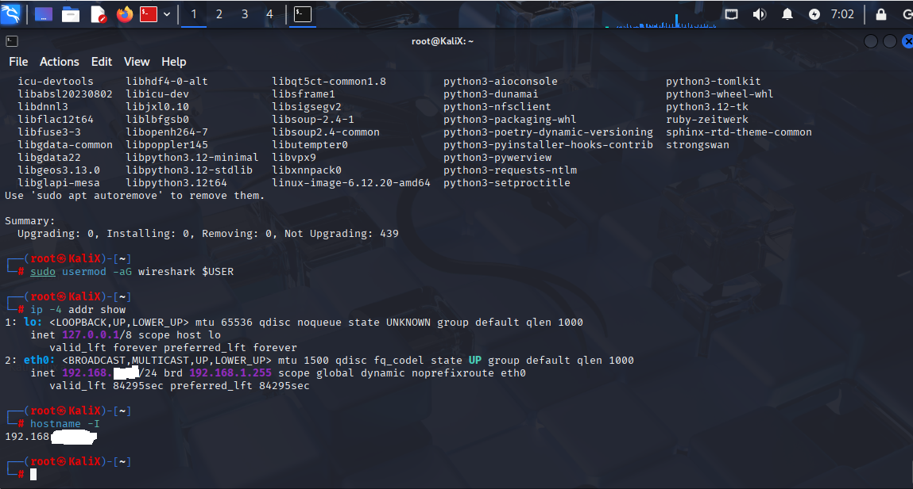

**$hostname -I**

* displays network/mask

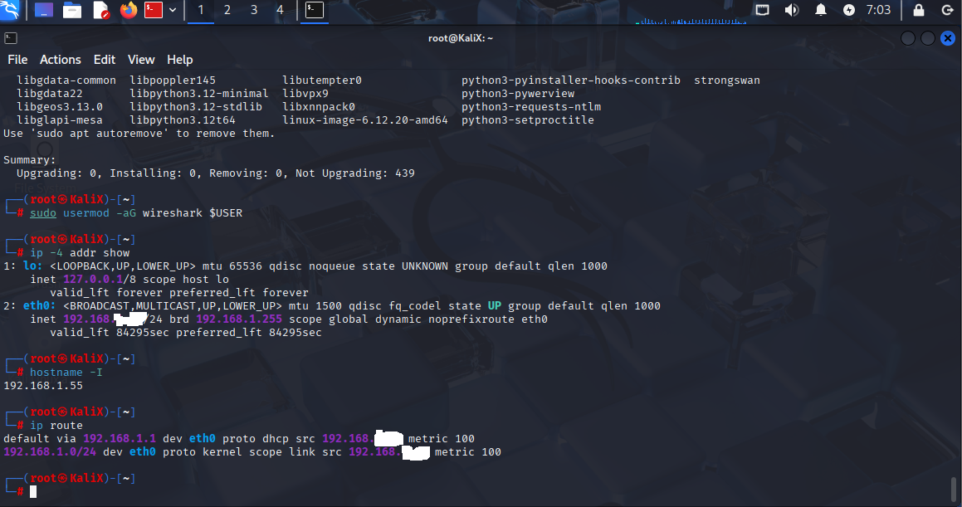

**$ip route**

* default via 192.168.1.1 dev eth0 proto dhcp src 192.168.--.-- metric 100

192.168.1.0/24 dev eth0 proto kernel scope link src 192.168.--.-- metric 100

1. **Basic TCP SYN network scan**

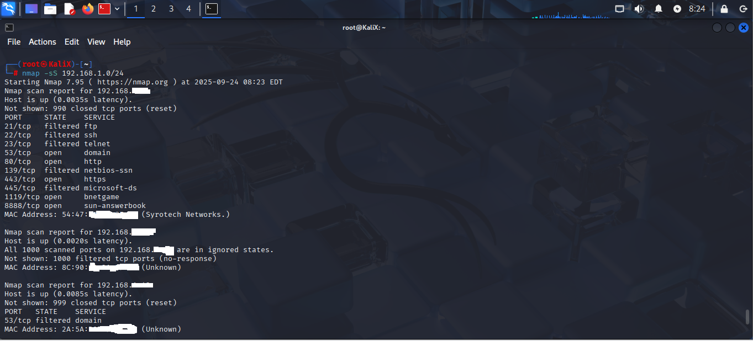

nmap -sS 192.168.1.0/24

-sS : TCP SYN

**Result:**

Starting Nmap 7.95 ( https://nmap.org ) at 2025-09-24 08:23 EDT

Nmap scan report for 192.168.1.--

Host is up (0.0035s latency).

Not shown: 990 closed tcp ports (reset)

**PORT STATE SERVICE**

53/tcp open domain

80/tcp open http

443/tcp open https

1119/tcp open bnetgame

8888/tcp open sun-answerbook

MAC Address: 54:47:--:--:--:-- (Syrotech Networks.)

Nmap scan report for 192.168.1.--

Host is up (0.0020s latency).

All 1000 scanned ports on 192.168.1.-- are in ignored states.

Not shown: 1000 filtered tcp ports (no-response)

MAC Address: 8C:90:--:--:--:-- (Unknown)

**Nmap scan report for 192.168.1.--**

Host is up (0.0085s latency).

Not shown: 999 closed tcp ports (reset)

PORT STATE SERVICE

53/tcp filtered domain

MAC Address: 2A:5A:--:--:--:-- (Unknown)

**Nmap scan report for 192.168.1.--**

Host is up (0.0011s latency).

All 1000 scanned ports on 192.168.1.-- are in ignored states.

**Not shown: 1000 filtered tcp ports (no-response)**

MAC Address: 28:16:--:--:--:-- (Intel Corporate)

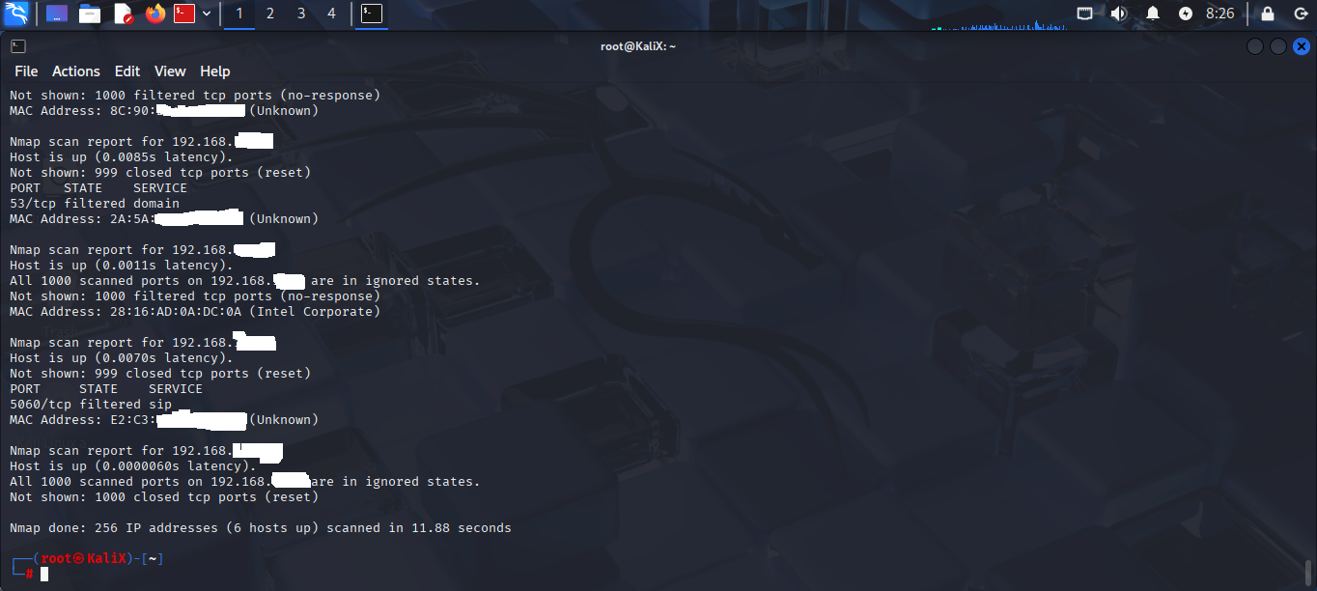

**Nmap scan report for 192.168.1.--**

Host is up (0.0070s latency).

Not shown: 999 closed tcp ports (reset)

PORT STATE SERVICE

5060/tcp filtered sip

MAC Address: E2:C3:--:--:--:-- (Unknown)

**Nmap scan report for 192.168.1.--**

Host is up (0.0000060s latency).

All 1000 scanned ports on 192.168.1.-- are in ignored states.

Not shown: 1000 closed tcp ports (reset)

Nmap done: 256 IP addresses (6 hosts up) scanned in 11.88 seconds

1. **Service & version detection + OS detection (more intrusive)**

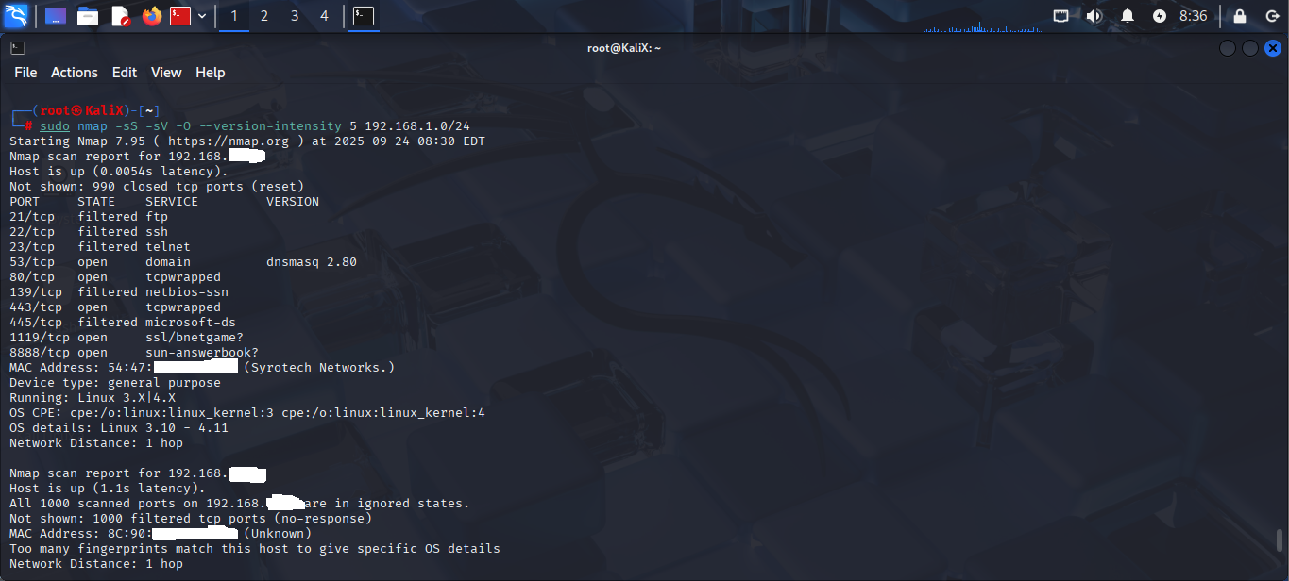

$ sudo nmap -sS -sV -O --version-intensity 5 192.168.1.0/24

* + -sV : service/version detection
  + -O : OS detection (requires root/admin)
  + --version-intensity : tweak how aggressive version detection is

tarting Nmap 7.95 ( https://nmap.org ) at 2025-09-24 08:30 EDT

Nmap scan report for 192.168.1.--

Host is up (0.0054s latency).

Not shown: 990 closed tcp ports (reset)

**PORT STATE SERVICE VERSION**

53/tcp open domain dnsmasq 2.80

80/tcp open tcpwrapped

443/tcp open tcpwrapped

1119/tcp open ssl/bnetgame?

8888/tcp open sun-answerbook?

MAC Address: 54:47:--:--:--:-- (Syrotech Networks.)

Device type: general purpose

Running: Linux 3.X|4.X

OS CPE: cpe:/o:linux:linux_kernel:3 cpe:/o:linux:linux_kernel:4

OS details: Linux 3.10 - 4.11

Network Distance: 1 hop

Nmap scan report for 192.168.1.--

Host is up (1.1s latency).

All 1000 scanned ports on 192.168.1.-- are in ignored states.

Not shown: 1000 filtered tcp ports (no-response)

MAC Address: 8C:90:--:--:--:-- (Unknown)

Too many fingerprints match this host to give specific OS details

Network Distance: 1 hop

Nmap scan report for 192.168.1.--

Host is up (0.059s latency).

Not shown: 999 closed tcp ports (reset)

PORT STATE SERVICE VERSION

53/tcp filtered domain

MAC Address: 2A:5A:--:--:--:-- (Unknown)

Too many fingerprints match this host to give specific OS details

Network Distance: 1 hop

Nmap scan report for 192.168.1.--

Host is up (0.00055s latency).

All 1000 scanned ports on 192.168.1.-- are in ignored states.

Not shown: 1000 filtered tcp ports (no-response)

MAC Address: 28:16:--:--:--:-- (Intel Corporate)

Too many fingerprints match this host to give specific OS details

Network Distance: 1 hop

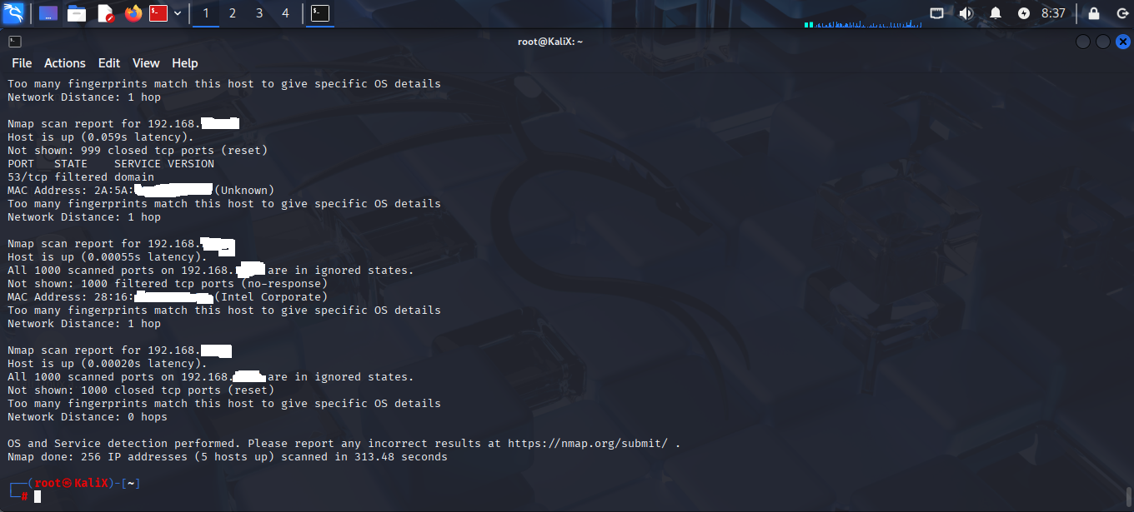

Nmap scan report for 192.168.1.--

Host is up (0.00020s latency).

All 1000 scanned ports on 192.168.1.-- are in ignored states.

**Not shown: 1000 closed tcp ports (reset)**

Too many fingerprints match this host to give specific OS details

Network Distance: 0 hops

OS and Service detection performed. Please report any incorrect results at https://nmap.org/submit/ .

Nmap done: 256 IP addresses (5 hosts up) scanned in 313.48 seconds

1. **UDP scan**

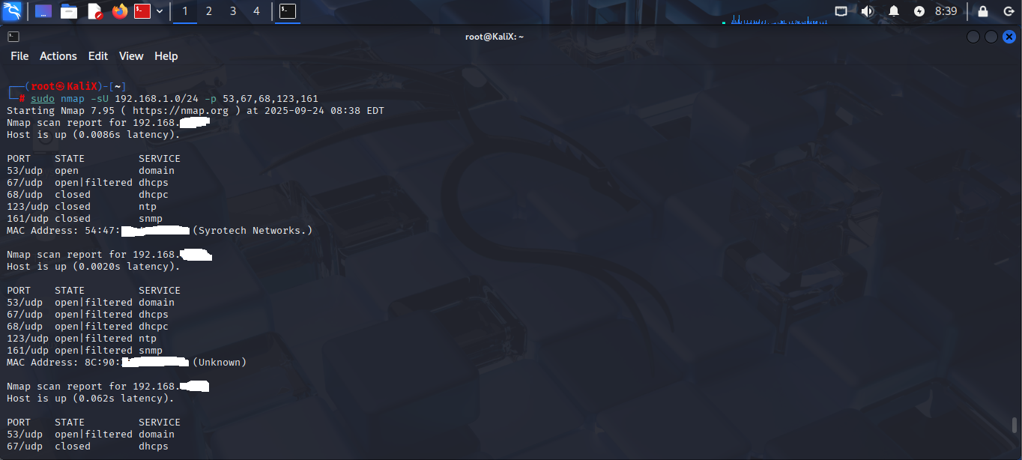

$sudo nmap -sU 192.168.1.0/24 -p 53,67,68,123,161

focus on common UDP ports first (53 DNS, 67/68 DHCP, 123 NTP, 161 SNMP).

**Result:**

Starting Nmap 7.95 ( https://nmap.org ) at 2025-09-24 08:38 EDT

Nmap scan report for 192.168.1.--

Host is up (0.0086s latency).

PORT STATE SERVICE

**53/udp open domain**

MAC Address: 54:47:--:--:--:-- (Syrotech Networks.)

Nmap scan report for 192.168.1.--

Host is up (0.0020s latency).

PORT STATE SERVICE

**53/udp open|filtered domain**

**67/udp open|filtered dhcps**

**68/udp open|filtered dhcpc**

**123/udp open|filtered ntp**

**161/udp open|filtered snmp**

MAC Address: 8C:90:--:--:--:-- (Unknown)

Nmap scan report for 192.168.1.--

Host is up (0.062s latency).

PORT STATE SERVICE

**53/udp open|filtered domain**

MAC Address: 2A:5A:--:--:--:-- (Unknown)

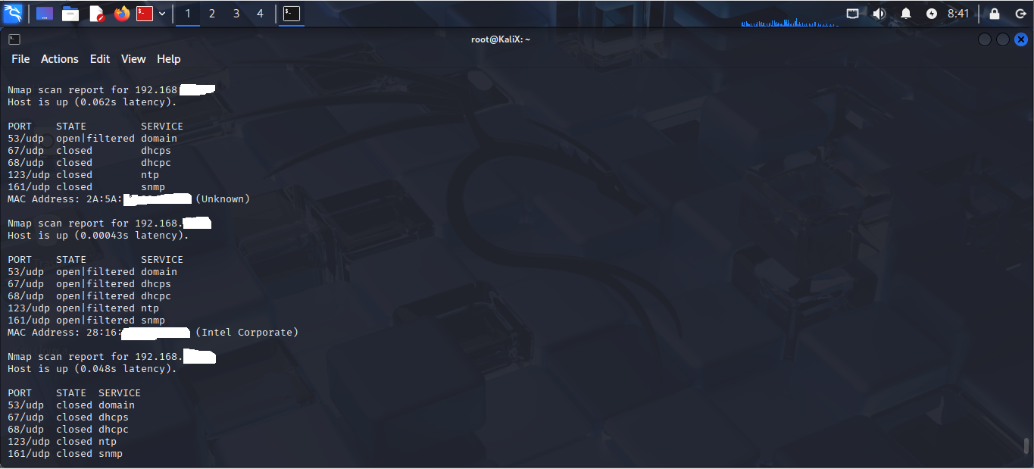

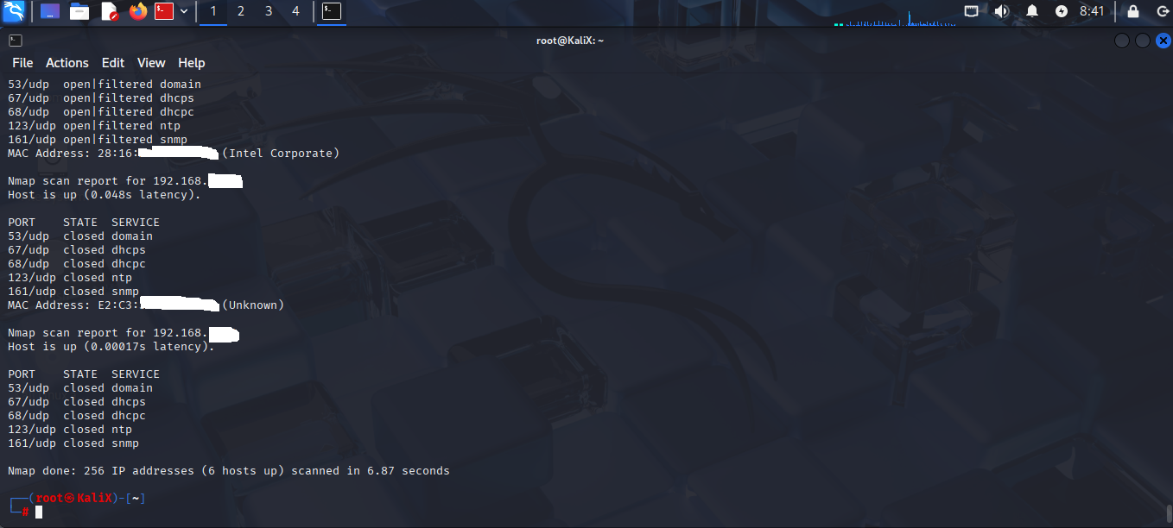

Nmap scan report for 192.168.1.--

Host is up (0.00043s latency).

PORT STATE SERVICE

**53/udp open|filtered domain**

**67/udp open|filtered dhcps**

**68/udp open|filtered dhcpc**

**123/udp open|filtered ntp**

**161/udp open|filtered snmp**

MAC Address: 28:16:--:--:--:-- (Intel Corporate)

Nmap scan report for 192.168.1.--

Host is up (0.048s latency).

PORT STATE SERVICE

MAC Address: E2:C3:--:--:--:-- (Unknown)

Nmap scan report for 192.168.1.--

Host is up (0.00017s latency).

Nmap done: 256 IP addresses (6 hosts up) scanned in 6.87 seconds